Invitation to Tender

Tender Name: Supply of Start Up Kits for Participants of Vocational Training Under BRICC Project | Tender No: NIG/DTR/TEN12
Location: Yobe State - Nigeria | Correspondence Language(s): English
Brief Summary Description of Project:

Mercy Corps, an International Non-Governmental Humanitarian Organization is pleased to invite Vendors/Suppliers to submit bids for Supply of Start Up Kits for Participants of Vocational Training in 11 communities of 2 LGA of Yobe state, Nigeria.

It is Mercy Corps decision to hold competitive bid for selection of vendors/suppliers who will be engaged to carry out the supply of the required items. Mercy Corps believe that competitive bids are the only way to fairly select the best company for the job while ensuring good prices and preventing collaboration and corruption.

Tender Package Available from:  19th / April / 2022: 8:00am | Tender Package Pickup Location:  Tender document can be downloaded through the following MC website: www.mcnigeria.com/tenders
Deadline for Offer Submission:  27th / April / 2022; 5:30pm | Submit Offers to:  Full bidding document with attachments.  Plot 109 – 112, Barewa Street, GRA, Damaturu – Yobe State or by online: tenders@mercycorps.org  Note: Envelopes or emails should be marked  NIG/DTR/TEN0012_ Supply of Start Up Kits for Participants of Vocational Training Under BRICC Project in Yobe State
Mercy Corps reserves the right to accept or reject any late offers

Questions and Answers (Q&A)
If any, Submit Questions in writing to: qa-ng-tenders@mercycorps.org Plot 109 – 112, Barewa Street, GRA, Damaturu – Yobe State
Last Day for Questions:  (22nd / April / 2022; 12:00 noon) | Questions will be answered by:  (23rd / April / 2022; 12:00 noon)
Questions will be answered through:

All prospective bidders will access consolidated questions and answers on the website alongside the tender package by 22nd April 2022 at 4.00 PM Nigeria time

Documentation Checklist
These documents are contained within this tender package: | - Invitation to Tender  - General Conditions for Tender  - Criteria and Submittals  - Price Offer Sheet  - Supplier Information Form  - Scope of Work/Technical Specifications/BoQ  - Sample Contract

General Conditions for Tender
Mercy Corps invites offers for the goods, services and/or works described and summarized in these documents, and in accordance with procedures, conditions and contract terms presented herein. Mercy Corps reserves the right to vary the quantity of work/materials specified in the Tender Package without any changes in unit price or other terms and conditions and to accept or reject any, all, or part of submitted offers.

2.1 Mercy Corps’ Anti-Bribery and Anti-Corruption Statement

Mercy Corps strictly prohibits:
- Any form of bribe or kickback in relation to its activities
This prohibition includes any request from any Mercy Corps employee, consultant or agent for anything of value from any company or individual in exchange for the employee, consultant or agents taking or not taking any action related to the award of a contract or the contract once awarded. It also applies to any offer from any company or individual to provide anything of value to any Mercy Corps employee, consultant or agent in exchange for that person taking or not taking any action related to the award of the contract or the contract.

- Conflicts of interests in the awarding or management of contracts
If a company is owned by, whether directly or indirectly, in whole or in part, any Mercy Corps employee or any person who is related to a Mercy Corps employee, the company must ensure that it and the employee disclose the relationship as part of or prior to submitting the offer.

- The sharing or obtaining of confidential information
Mercy Corps prohibits its employees from sharing, and any offerors from obtaining, confidential information related to this solicitation, including information regarding Mercy Corps’ price estimates, competing offerors or competing offers, etc. Any information provided to one offeror must be provided to all other offerors.

- Collusion between/among offerors
Mercy Corps requires fair and open competition for this solicitation. No two (or more) companies submitting bids can be owned or controlled by the same individual(s). Companies submitting offers cannot share prices or other offer information or take any other action intended to pre-determine which company will win the solicitation and what price will be paid.

- Any form of exploitation, abuse, human trafficking or internal sexual misconduct
Mercy Corps requires its partners to adhere to its Safeguarding policies including the its policies on Child Safeguarding, Prevention of Sexual Exploitation and Abuse of Beneficiaries and Community Members, Anti-Trafficking and Sexual Misconduct (available at https://www.mercycorps.org/who-we-are/ethics-policies). Companies will be expected to ensure that they have the capacity to abide by these policies, that their employees and subcontractors understand these policies, and that they communicate to its employees and subcontractors the duty to report any violation or suspected violation. Mercy Corps will not engage with a company that is found to be in violation of these policies.

Violations of these prohibitions, along with all evidence of such violations, should be reported to:
intergrityhotline@mercycorps.org

Mercy Corps will investigate allegations fully and will take appropriate action. Any company, or individual that participates in any of the above prohibited conduct, will have its actions reported to the appropriate authorities, will be investigated fully, will have its offer rejected and/or contract terminated, and will not be eligible for future contracts with Mercy Corps. Employees participating in such conduct will have his/her employment terminated.

Violations will also be reported to Mercy Corps’ donors, who may also choose to investigate and debar or suspend companies and their owners from receiving any contract that is funded in part by the donor, whether the contract is with Mercy Corps or any other entity.

2.2 Tender Basis:

- All offers shall be made in accordance with these instructions, and all documents requested should be furnished, including any required (but not limited to) supplier-specific information, technical specifications, drawings, bill of quantities, and/or delivery schedule. If any requested document is not furnished, a reason should be given for its omission in an exception sheet.

- No respondent should add, omit or change any item, term or condition herein.

- If suppliers have any additional requests and conditions, these shall be stipulated in an exception sheet.

- Each offeror may make one response only.

- Each offer shall be valid for the period of [180 days] from its date of submission.

- All offers should indicate whether they include taxes, compulsory payments, levies and/or duties, including VAT, if applicable.

- Suppliers should ensure that financial offers are devoid of calculation errors. If errors are identified during the evaluation process, the unit price will prevail. If there is ambiguity on the unit price, the Selection Committee may decide to disqualify the offer.

- Any requests for clarifications regarding the project that are not addressed in written documents must be presented to Mercy Corps in writing. The answer to any question raised in writing by any offeror will be issued to that offeror. In some cases Mercy Corps may choose to issue clarifications to all offerors. It is a condition of this tender that no clarification shall be deemed to supersede, contradict, add to or detract from the conditions hereof, unless made in writing as an Addendum to Tender and signed by Mercy Corps or its designated representative.

- This Tender does not obligate Mercy Corps to execute a contract nor does it commit Mercy Corps to pay any costs incurred in the preparation and submission of bids. Furthermore, Mercy Corps reserves the right to reject any and all offers, if such action is considered to be in the best interest of Mercy Corps.

2.3 Supplier Eligibility
Suppliers may not apply, and will be rejected as ineligible, if they :
- Are not registered companies

- Are bankrupt or in the process of going bankrupt

- Have been convicted of illegal/corrupt activities, and/or unprofessional conduct

- Have been guilty of grave professional misconduct

- Have not fulfilled obligations related to payment of social security and taxes

- Are guilty of serious misinterpretation in supplying information

- Are in violation of the policies outlined in Mercy Corps Anti Bribery or Anti Corruption Statement

- Supplier (or supplier’s principals) are on any list of sanctioned parties issued by; or are presently excluded or disqualified from participation in this transaction by: the United States Government or United Nations by the United States Government, the United Kingdom, the European Union, the United Nations, other national governments, or public international organizations.

Additional eligibility criteria, if applicable, are stated in section 3.2 of this tender package.

2.4 Response Documents

Offerors must submit an offer in their own format and ensure it contains all the required documents and information specified in this tender. Where an itemized Price Offer Sheet is included in the tender package, the offeror must complete and submit it with the rest of their offer.

2.5 Acceptance of Successful Response

Documentation submitted by offerors will be verified by Mercy Corps. The winning offeror will be required to sign a contract for the stated, agreed upon amount.

2.6 Certification Regarding Terrorism
It is Mercy Corps’ policy to comply with humanitarian principles and the laws and regulations of the United States, the European Union, the United Nations, the United Kingdom, host nations, and other applicable donors concerning transactions with or support to individuals or entities that have engaged in fraud, waste, abuse, human trafficking, corruption, or terrorist activity. These laws and regulations prohibit Mercy Corps from transacting with or providing support to any individuals or entities that are the subject of government sanctions, donor rules, or laws prohibiting transactions or support to such parties.

Criteria & Submittals
3.1 Contract Terms
Mercy Corps intends to issue a Fixed Price contract to one or several company (ies) or organization(s). The successful offeror(s) shall be required to adhere to the statement of work and terms and conditions of the resulting contract. The anticipated contract is incorporated in Section 6 herein. By submitting an offer, offerors certify that they understand and agree to all of the terms and clauses contained in Section 6.
3.2 Specific Eligibility Criteria
In keeping with Mercy Corps’ guiding principle for procurement, Mercy Corps Nigeria Uses only responsible service providers that possess the ability to perform successfully under the terms and conditions of a proposed procurement. In addition to the ability to perform, Mercy Corps also consider minimum standards of responsibility to determine which Service provider(s) Mercy Corps will do business with. These standards include;
- Being eligible business under applicable laws and regulations of the Federal Republic of Nigeria
- Being in good standing with any taxation or legal authority in Nigeria
- Having a satisfactory record of performance and business and ethics based on information available to Mercy Corps
Below are set of supplier’s eligibility criteria that form part of the above mentioned standards
- The business must be registered and incorporated under the laws of Nigeria with corporate Affairs Commission (CAC)
- The business must be registered with CAC and FIRS and has a Tax Identification Number (TIN) and EFCC certificate
- The business must have a valid address
- The business is not bankrupt or in the process of going bankrupt
- The business/owners have not been convicted of an offence concerning professional conduct
- The business/owners have not been guilty of grave professional misconduct (proven by any means that the contracting authorities can justify).
- The business has fulfilled obligations related to payment of social security and taxes
- The business is not guilty of serious misinterpretation in supplying information
- The business is not in situation of conflict of interest (with prior relationship to project or family or business relationship to parties on commission)
- The business does not employ personnel below the legal working age.
- The business provides basic social right and fair working conditions to the employees.
- The business/Owners are not on any list of sanctioned parties issued by the United States Government and/or United Nations and European Union.
3.3 Tender Submittals
Documents and required information listed in tender submittals are necessary in order to support the eligibility criteria and to conduct technical evaluations of received offers (and due diligence). While absence of these documents and/or information does not denote mandatory disqualification of suppliers, the lack of these items has the potential to severely and negatively impact the technical evaluation of an offer.

Documents supporting the Eligibility Criteria:
- Must be registered in Nigeria with evidence of registration attached
- A copy of corporate tax certificate and/or Tax Clearance
- A copy of signed and stamped offer sheet and supplier information form

Documents to conduct the Technical Evaluation and additional Due Diligence:
      - Business Profile, with location address and branches if any, services provided with evidence of registration with CAC attached (2 Pages maximum)
      - Evidence of similar projects; successfully executed similar works not more than 3 years (Contract documents, Task Order, Purchase Orders, Certificate of Completion e.t.c).
      - Evidence of financial capacity/banking support to execute the contract if successfully selected (Company’s bank account statement for the past one year or letter of credit from a reputable financial institution as well as letter of credibility from their Bank).
- Letter stating acceptance of Mercy Corps payment terms of 100% payment after completion of project (Letter to be drafted on the company’s letter head, signed, stamped, and dated by the Director or CEO of the company).

Price Offer:

The Price offer is used to determine which offer represents the best value and serves as a basis of negotiation before award of a contract. As a Fixed-Price contract, the price of the contract to be awarded will be an all-inclusive fixed price basis, either in the form of a total fixed price or a per-unit/deliverable fixed price. As a Cost Reimbursement plus Fixed Fee contract, the price of contract to be awarded will be on the basis of estimated costs at cost and specified fee paid; the contract to be awarded will have a ceiling amount not to be exceed without prior written approval. As a Time and Materials contract, the price of contract to be awarded will be on the basis of estimated direct labor hours/days at specified fixed hourly/daily rates and materials at cost; the contract to be awarded will have a ceiling amount not to be exceeded without prior written approval. No profit, fees, taxes, or additional costs can be added after contract signing. Offerors must show unit prices, quantities, and total price, as displayed in the Offer Sheet in Section 4. All items must be clearly labeled and included in the total offered price.
Offerors must not include VAT and customs duties in their offer However; Mercy corps charges 5% withholding Tax in line with government regulation in Nigeria.
3.4 Currency
Offers should be submitted in: Nigeria Naira (NGN)
Payments will be made in: Nigeria Naira (NGN) Through wire transfer

3.5 Tender Evaluation (LPTA Selection Method)
Based on the above submittals, a Mercy Corps Tender Committee will conduct a tender evaluation process. Mercy Corps reserves the right to accept or reject any or all proposals, and to accept the offer(s) deemed to be in the best interest of Mercy Corps. MC will not be responsible for or pay for any expenses or losses which may be incurred by any Offeror in the preparation of their tender.
Evaluations will be conducted as described in the following subsections:
3.5.1 Scoring Evaluation
LPTA Method Lowest Price, Technically Acceptable (LPTA)
Mercy Corps Tender Committee will conduct a technical evaluation which will grade technical criteria on a pass/fail basis. Supplier’s bids must meet the minimum technical standard established here in order to receive a passing mark. Any offerors who receive a failing mark on any criteria will be automatically disqualified from the tender process.
Only offerors who pass all criteria will move on to the next round of evaluation.
Pass/fail technical criteria are as follows:
Technical Criteria | Pass or Fail?
Business Profile, with location address and branches if any, services provided with evidence of registration with CAC attached (2 Pages maximum)
Evidence of similar projects; successfully executed similar works not more than 3 years (letter of award, contract documents, Purchase Orders, certificate of completion etc..)
Evidence of financial capacity/banking support to execute the contract if successfully selected (Company’s bank account statement for the past one year or letter of credit from a reputable financial institution)
Letter stating acceptance of Mercy Corps payment terms of 100% payment after completion of project (Letter to be drafted on the company’s letterhead, signed, stamped and dated by the Director or CEO of the company)

3.5.2 Financial Evaluation and Price/Cost Analysis
All suppliers who passed all technical criteria will move on to the financial evaluation where the lowest price offer(s) will be accepted as the winning offeror(s) assuming the price is deemed fair and reasonable and subject to the additional due diligence in section 3.5.3.

3.5.3 Additional Due Diligence
Upon completion of both the technical and financial evaluations, Mercy Corps may choose to engage in additional due diligence processes with a particular supplier or supplier(s). The purpose of these processes is to ensure that Mercy Corps engages with reputable, ethical, responsible Suppliers with solid financials and the ability to fulfill the contract. Additional due diligence may take the form of the following processes (though it is not limited to):
- Reference Checks
- Supplier’s facility visits
- Analysis of audited financial statements
- Determination of relations and affiliations between offerors
- Other appropriate documented method giving Mercy Corps increased confidence in the supplier’s ability to perform.
- RPS on Demand

Offer Form
Offerors must submit their own independant offer including at least (but not limited to):

- All documents requested in the “Eligibility Criteria” section of this Tender Package
- All documents requested in the “Tender Submittals” section of this Tender Package
- All information listed in the “Documents Comprising the Bid” section below

All offers must be duly signed (including position and full name of the signer) and stamped, with the date of completion.

Documents Comprising the Bid

The following information must be included in the offer of any potential offeror:

- Cover Letter explaining interest to be a contracted vendor or supplier, and the details of the Proposal. The content of the cover letter shall include the following information:

- A detailed specification of the offered goods, services and/or works (Proposal)

- Warranty (if necessary and appropriate)

- Delivery time

- Price validity date (for this purpose and as stated on the advertisement, quote given shall remain unchanged for 180 working days)

- A Price Offer detailing the unit price only using the Price Offer Sheet template provided in section 7

- Completed and signed Mercy Corps Supplier Information Form (template provided in section 7)
- Other important documents offeror feels need to be attached to support their bid
The original bid shall be signed by the offeror or a person or persons duly authorized to bind the offeror to the contract. Financial offer pages of the bid shall be initialed by the person or persons signing the bid and stamped with the company seal.

Any interlineations, erasures, or overwriting shall be valid only if they are initialed by the person or persons signing the bid.

Scope of Work/Technical Specifications
Mercy Corps is an international relief and development organization working in over 43 countries worldwide helping people build secure, productive, and just communities. Mercy Corps in Nigeria implements a variety of programs with the ultimate goal of building productive, secure and just communities. Since 2012 Mercy Corps have been developing a strong and productive relationship that seeks to “power sustainable social and business progress through cross-sector collaboration and improve the lives of people and their communities in our shared geographies, in recognition of the nearly two billion people now living in countries where our partnership goals are threatened by fragility, conflict and violence.

Mercy Corps is pleased to invite qualified suppliers to submit bids for the Supply of Startup kits for trained Youths across 11 communities of Damaturu and Potiskum LGAs namely, Damakasu, Gwange, Murfa, Nayinawa, Pompomari and Kallalawa-Gabai as well as Barebare Bauya, Dogo Tebo, Hausawa Asibiti, Mamudo and Yerimaram. Yobe state. Nigeria. The successful suppliers will sign a Purchase Contract with Mercy Corps for a period of three (3) weeks delivery time. Items price will be fixed for the period of this contract and delivery locations be within Yobe State.

The suppliers will be engaged using an approved Purchase Contract which will contain information about the item’s specifications, Delivery time and location, payment term, and penalty clause should any of the party failed in its obligations as agreed under the contract.

It is Mercy Corps decision to hold competitive bid for selection of vendors/suppliers who will be engaged to carry out the supply of the required items.

Mercy Corps believe that competitive bids are the only way to fairly select the best company for the job while ensuring good prices and preventing collaboration and corruption.

Vendor/ Supplier will be engaged using a Purchase Contract which will spell out the obligation of both parties and well as other terms and condition which will be attached as annexes

5.2 Item Description/Specification: See Attachment 2 – Price Offer Sheet

6. Sample Contract
This is the anticipated contract. However, if required, additional terms and conditions may be added by Mercy Corps in the final contract.

PURCHASE CONTRACT
Contract No. _______

THIS PURCHASE CONTRACT (the “Contract”) entered into as of __________ by and between MERCY CORPS, a State of Washington, U.S.A. nonprofit corporation having its principal office in Portland, Oregon, U.S.A. (“Mercy Corps”) and _____________________________ ("Supplier") is as follows:
- Defined Terms. Each of the following terms has the meaning given to such term on Schedule I attached hereto: Authorized Representative, Contract Number, Delivery Date, Delivery Location, Delivery Terms, Donor Terms, Goods, Packing Requirements, Pricing, and Specifications. Other terms are defined as specified throughout this Contract.
- Purchase and Sale of Goods. Supplier will sell to Mercy Corps, and Mercy Corps will purchase and pay for, the Goods in accordance with the terms and conditions set forth in this Contract.
- Specifications. The Goods must strictly comply with or exceed the Specifications listed in Schedule II. No deviation, substitution or change is permitted without Mercy Corps’ prior written consent.
- Purchase Order Amendments. Mercy Corps may suspend Supplier's performance, increase or decrease the ordered quantities, or make changes for Mercy Corps’ reasonable business needs by written notice to Supplier (each, a “Purchase Order Amendment"). Unless mutually agreed, a Purchase Order Amendment does not apply to change the Goods timely and fully delivered and accepted before the date of the Purchase Order Amendment. If any change causes an increase or decrease in the cost of, or the time required for, Supplier's performance, an equitable adjustment may be made in the price or delivery schedule or both, if such adjustment is set forth in a Purchase Order Amendment signed by the Authorized Representative.
- Non-Exclusivity. This Contract is not intended to create an exclusive relationship between the parties.
- Inspection, Acceptance and Rejection.
  - All Goods will be subject to Mercy Corps' inspection and testing (which may be done by a third party authorized by Mercy Corps), at any time and place, including the period of manufacture/production/creation and before final acceptance. If Mercy Corps inspects or tests at Supplier's premises, Supplier, without additional charge, will provide all reasonable facilities and assistance for the safety and convenience of Mercy Corps' inspectors. No inspection or testing done or not done before final inspection and acceptance will relieve Supplier from responsibility for defects or for other failure to meet the requirements of this Contract. Notwithstanding any prior inspections or payments made, all Goods will be subject to final inspection and acceptance at the Delivery Location within a reasonable time after delivery (but in no event, less than three days after the date of delivery).
  - Acceptance will occur only when the Authorized Representative delivers written, signed notice of acceptance to Supplier in the form of a goods received notice (“GRN”) and such notice has been signed by Supplier’s representative. The GRN must include: (1) the GRN number and the packing slip number; (2) the Contract number; (3) a description of the Goods; (4) the quantity delivered; (5) final inspection date and location; (6) quantity accepted; and (7) quantity rejected or over-shipped.
  - If any delivery, documentation or the Goods delivered do not comply with all of the terms and conditions of this Contract, Mercy Corps may do one or more of the following: (1) reject such nonconforming Goods, accept conforming Goods and reduce the purchase price by such amount as Mercy Corps determines in good faith reflects the value to Mercy Corps of the accepted Goods, (2) accept such nonconforming Goods and reduce the purchase price by such amount as Mercy Corps determines in good faith reflects the reduced value to Mercy Corps of such nonconforming Goods; (3) reject all Goods; and/or (4) terminate this Contract without any further obligation on Mercy Corps’ part.
  - If any Goods are finally accepted, Mercy Corps will only pay for the quantity accepted up to the quantity specified in this Contract. Mercy Corps will in no event pay for quantity above the amount provided for in this Contract or accepted. Mercy Corps or its agent will hold over-shipments and non-conforming shipments at Supplier's risk and expense for a reasonable time awaiting Supplier's instructions. Supplier will bear the expense of return charges, storage charges and other expenses for over-shipped quantities and Goods not accepted.
- Packing. All Goods will be prepared for shipping and delivery and will be shipped in accordance with the Packing Requirements listed in Schedule I. Price based on weight will include net weight only. Supplier will not charge Mercy Corps for packaging or pre-shipping costs, such as boxing, crating, handling damage, drayage, or storage. Supplier will mark all containers with necessary handling and shipping information, Contract Number, date of shipment, and names of the consignee and consignor. A packing list, and other documentation required for domestic or international transit, regulatory clearance or identification of the Goods will accompany each shipment.
- Transportation, Shipment and Delivery. Shipment/transportation will be in accordance with the Delivery Terms, Delivery Date, and Delivery Location in Schedule I. Mercy Corps will not be charged for shipping, delivery, loading or unloading costs unless otherwise specified in the Delivery Terms.
- Risk of Loss. Supplier will bear all risk of loss, damage, or destruction to the Goods, in whole or in part, occurring before final acceptance by Mercy Corps at the Delivery Location; provided, Mercy Corps is responsible for any loss caused by its gross negligence.
- Taxes, Duties and Expenses.
  - All taxes, duties and other governmental charges with respect to the manufacture/production/creation of the Goods and the delivery of the Goods to Mercy Corps in accordance with this Contract will be the liability of, and borne solely by, Supplier. If the law requires Mercy Corps to withhold taxes from payments to Supplier, Mercy Corps may withhold those taxes and pay them to the appropriate taxing authority. Mercy Corps will deliver to Supplier an official notice for such taxes. Mercy Corps will use reasonable efforts to minimize any taxes withheld to the extent allowed by law.
  - Supplier is responsible for all expenses incurred by it in performing under this Contract.
- Invoicing and Payment.
  - Mercy Corps will have no obligation to make any payment to Supplier with respect to the Goods until final acceptance in accordance with Section 6(b) and delivery of an invoice that fully complies with the requirements specified in this Contract. Invoices may only be submitted after Supplier receives a GRN. Invoices must be submitted within 60 days of Supplier’s acceptance of a GRN. Mercy Corps will have no obligation to pay an invoice submitted after 60 days or to pay an invoice amount that Mercy Corps disputes in a written notice to Supplier. Each invoice must contain or attach the following: (1) a copy of the signed GRN; (2) Supplier’s name and address; (3) description of the Goods delivered, delivery date, quantity, unit price and total price to be paid; (4) all information necessary for Mercy Corps to implement payment (e.g., name of representative to address payment to, address, bank account information as applicable for the method of payment); (5) the Contract Number; (6) packing slip number; (7) taxes and duties (only if payable by Mercy Corps per the terms of this Contract); (8) Delivery Location and Delivery Date; and (9) any other information reasonably required by Mercy Corps. Invoices will only be deemed received on the date they are delivered to the Authorized Representative and in full compliance with the requirements herein.
  - Mercy Corps will make payment within 30 days of receipt of Supplier's fully conforming invoice. Payment of an invoice will not constitute acceptance of Goods, and is subject to adjustment for errors, shortages, defects or other failure of Supplier to meet the requirements of this Contract. Mercy Corps may set-off amounts owed to Mercy Corps against an amount Mercy Corps owes to Supplier or Supplier's affiliated companies, and Mercy Corps will provide notice to Supplier within a reasonable time after the setoff.
- Representations, Warranties and Additional Covenants. Supplier represents and warrants to Mercy Corps and covenants with Mercy Corps as follows.
  - Supplier has full rights and authority to enter into and perform its obligations under this Contract. Supplier’s performance will not violate any agreement or obligation between Supplier and any third party.
  - The Goods and all documentation required will meet each of the standards and specifications set forth in this Contract. The Goods are merchantable and fit for their intended purpose, comply with all applicable law and are free from all defects in material and workmanship.
  - Supplier will deliver good and marketable title to the Goods free and clear of all liens, claims, encumbrances and interests of any other person, entity or government. The Goods will not infringe on any patent, copyright, trademark, trade secret or other proprietary right of any third party.
  - Supplier will comply with all applicable law, regulations and rules in the performance of its obligations under this Contract.
  - Supplier has not, and will not, engage in transactions with, or provide resources or support to, individuals and organizations associated with terrorism, including those individuals or entities that appear on the Specially Designated Nationals and Blocked Persons List maintained by the U.S. Treasury (http://www.treasury.gov/resource-center/sanctions/SDN-List/Pages/default.aspx) or the United Nations Security designation list (http://www.un.org/sc/committees/1267/aq_sanctions_list.shtml).
  - Supplier will comply with and train its employees in all applicable laws against bribery, corruption, inaccurate books and records, inadequate internal controls and money-laundering, including the U.S. Foreign Corrupt Practices Act and the UK Bribery Act. Supplier has not and will not offer or give any employee, agent, or representative of Mercy Corps anything of value to secure any business from Mercy Corps or influence such person to alter the terms, conditions, or performance of any contract with or purchase order from Mercy Corps, including but not limited to this Contract.
  - Supplier does not own, directly or indirectly, any other company that was competing for award of this Contract. Supplier did not seek or obtain confidential information related to the award of this Contract from any Mercy Corps employee, agent or representative. Supplier did not collude or conspire with any other individual or entity to limit competition for the award of this Contract, to set prices being offered or in any other way to interfere with free and open competition.
  - Supplier is not owned in whole or in part, directly or indirectly, by any immediate or extended family member of any Mercy Corps employee, agent or representative, or, if so owned, Supplier fully disclosed such relationship and any potential conflict of interest has been waived by Mercy Corps.
  - Supplier has not engaged in, and will not engage in, any of the following conduct: (A) trafficking in persons (as defined in the Protocol to Prevent, Suppress, and Punish Trafficking in Persons, especially Women and Children, supplementing the UN Convention against Transnational Organized Crime); (B) procuring a commercial sex act; or (C) using forced labor.
  - Supplier is not the subject or any governmental or donor investigation and has not been debarred or suspended by any government, governmental agency or donor.
  - Contractor [or supplier] understands that it is subject to Mercy Corps' Child Safeguarding, Prevention of Sexual Exploitation and Abuse of Beneficiaries and Community Members, Anti-Trafficking and Sexual Misconduct policies (available at https://www.mercycorps.org/who-we-are/ethics-policies). Contractor must report any violation or suspected violation of these policies in relation to the Contractor's activities under this contract to Mercy Corps, which may be done via its Integrity Hotline website (www.mercycorps.org/integrityhotline). Contractor will ensure that it has the capacity to abide by these policies, that its employees and subcontractors understand these policies, and that it communicates to its employees and subcontractors the duty to report. Contractor understands and agrees that a violation of these policies may, in addition to any other remedies available under this Contract or at law, result in suspension or immediate termination of this Contract and may also result in Contractor being deemed ineligible for future contracts with Mercy Corps.
  - Independent Contractor. The parties intend to be independent contractors. Supplier will be solely responsible for and have control over the means, methods, techniques, personnel and procedures for supplying goods. Neither party will be deemed an agent or partner of the other party.
- Confidentiality. Supplier will maintain the confidentiality of: (i) any information Mercy Corps provides to Supplier that Mercy Corps identifies as confidential; (ii) the terms and conditions of this Contract; and (iii) nonpublic information regarding Mercy Corps’ policies and practices. Upon Mercy Corps’ request, Supplier will return to Mercy Corps all confidential information provided by Mercy Corps to Supplier. This confidentiality obligation will survive final acceptance of the Goods, payment of the purchase price and termination of this Contract.
- Indemnification. Supplier will indemnify Mercy Corps and each of its officers, directors, employees, representatives and agents (each, an “Indemnitee”), and hold them harmless from, any and all losses, claims, damages, liabilities, any government or donor investigations, fines or penalties and related expenses (including incidental and consequential damages and reasonable attorneys’ fees, whether incurred at the investigative, trial or appellate level or otherwise) incurred by any Indemnitee or asserted against any Indemnitee by any third party or by Supplier arising out of, in connection with, or as a result of this Contract, any failure by Supplier to fully perform its obligations under this Contract or any breach by Supplier of any of its representations and warranties under this Contract, provided that such indemnity will not, as to any Indemnitee, be available to the extent that such losses, claims, damages, liabilities or related expenses resulted from the gross negligence or willful misconduct of such Indemnitee. This indemnity obligation will survive final acceptance of the Goods, payment of the purchase price and termination of this Contract.
- Termination and Remedies. This Contract may be terminated under the following circumstances:
  - by both Parties on mutual written agreement of the Parties;
  - by Mercy Corps immediat
  - ely upon written notice in the event Mercy Corps’ donor(s) terminates or withdraws funding that Mercy Corps would use to pay Contractor under this Contract;
  - by either Party due to the non-terminating Party’s breach of this Contract and failure to correct such breach within 15 days prior notice of such breach;
  - be either Party upon written notice if a force majeure event, including any not reasonably foreseeable war, insurrection, change in law or government action or inaction, strike, natural disaster or similar event, prevents the terminating Party from being able to fulfill its obligations under this Contract; or
  - by Mercy Corps immediately upon written notice if Mercy Corps using its sole discretion determines that Contractor has or will breach any of its warranties, covenants or representations in this Contract, in which case Mercy Corps may withhold any and all amounts owed to Contractor until such breach is remedied.
In the event termination is due to Mercy Corps’ breach of this Contract, by Mercy Corps for Mercy Corps convenience, due to force majeure event, or due to loss of funding, Mercy Corps shall be obligated to pay Contractor for its reasonable, pro-rated costs of work completed and expenses properly incurred prior to termination.
If Mercy Corps determines that Supplier has or will breach any of its warranties, covenants or representations in this Contract, Mercy Corps may, in addition to any other remedies for such breach available at law or in equity, (i) terminate this Contract; (ii) reject any Goods delivered; (iii) return any Goods already accepted and obtain full repayment for any amount paid for such Goods; (iv) if Supplier breaches Section 10(j), withhold payment until such investigation, suspension or debarment is lifted; and (v) if Supplier breaches any of Section 10(e), (f), (g), (h) or (i), not pay for any Goods that have been accepted but that have been consumed or otherwise cannot be returned to Supplier and report the breach to Mercy Corps donors and appropriate governmental authorities.
[ALTERNATIVE CLAUSE If USING LIQUIDATED DAMAGES -DELETE IF NOT APPLICABLE]: [If Mercy Corps determines that Supplier has or will breach any of its warranties, covenants or representations in this Contract, Mercy Corps may terminate this Contract. Supplier’s breach of its obligations under this Contract will result in Mercy Corps incurring damages in an amount that will be difficult to establish and leave Mercy without an adequate remedy. Accordingly, the parties agree that the following liquidated damages are reasonable in light of the anticipated harm caused by any such breach: [insert dollar amount or other formula for determining the amount of damages].]
- Dispute Resolution. Any unresolved dispute or claims will be settled by arbitration administered by the International Centre for Dispute Resolution in accordance with its International Arbitration Rules. The number of arbitrators will be one. The place of arbitration will be Portland, Oregon. The language of the arbitration will be English.
- Access to Books and Records. Mercy Corps, its donors (including, if applicable, USAID, and the Comptroller General of the United States) and any of their respective representatives will have access to any books, documents, papers and records of Supplier that are directly pertinent to this Contract for the purpose of making audits, examinations, excerpts and transcriptions or a period of seven years following the completion of the Contract.
- Additional Donor Terms and Conditions. The Donor Terms (if any) are incorporated in this Contract by reference and are fully binding on Supplier and Mercy Corps. In the event of a conflict between the Donor Terms and this Contract or any other document between Supplier and Mercy Corps, the Donor Terms will prevail.
- Miscellaneous.
  - This Contract and the rights and obligations of the parties hereto will be governed by and construed in accordance with the laws of the State of Oregon (exclusive of the United Nations Convention on Contracts for the International Sale of Goods), without regard to the conflict of laws provisions thereof.
  - No right or obligation under this Contract (including the right to receive monies due) will be assigned without the prior written consent of Mercy Corps. Any assignment without such consent will be void. Mercy Corps may assign its rights under this Contract.
  - All notices provided for herein will be in writing and will be delivered by hand or overnight courier service, email or fax in accordance with each party’s contact information set forth on Schedule I. Notices will be deemed to have been given when received, provided that notices sent by email or fax will be deemed received when sent (except that, if not sent during normal business hours for the recipient, will be deemed received at the opening of business on the next business day for the recipient).
  - Time is of the essence of each and every obligation of Supplier under this Contract.
  - If any provision of this Contract is prohibited by or invalid under applicable law, such provision will be ineffective only to the extent of such prohibition or invalidity without invalidating the remainder of such provision or any remaining provisions of this Contract.
  - Except as otherwise provided above, this Contract may be amended or modified only by a written document signed by both parties. This Contract constitutes the entire contract between the parties relating to the subject matter hereof and supersedes any and all previous Contracts and understandings, oral or written, relating to the subject matter hereof.
IN WITNESS WHEREOF, this Purchase Contract has been duly executed as of the date first written above.

MERCY CORPS  By:  Name:  Title: | ________________________________  By:  Name:  Title:

SCHEDULE I

Additional Terms
- Goods: ________________________ (the “Goods”). All Goods must precisely comply with the specifications attached hereto as Schedule II (the “Specifications”).
- Quantity: ______________________.
- Packing Requirements: _________________________ (the “Packing Requirements”).
- Delivery Location: ______________________________ (the “Delivery Location”).
- Delivery Date: __________________________________ (the “Delivery Date”).
- Transportation and Unloading Terms: ________________________.
- Pricing:
  - Unit Price(s): _________________ (the “Unit Price(s)”).
  - Total Price: __________________ (the “Price”)
- Additional Payment Terms (if any): [If applicable, include any invoicing or payment terms that differ from the standard contract and include the following statement: “To the extent necessary to ensure consistency between these terms and the terms of the Purchase Contract, in the event of inconsistency the terms in this clause shall prevail.”] [If not applicable, simply state “Intentionally Omitted.”]
- Authorized Representatives and Contact Information:
  - Mercy Corps: Only the following Mercy Corps employees are authorized to agree to any amendment of this Contract and any Change Order:
__________________
__________________
__________________
Attn: _____________
Fax: _____________
Email: _____________
Only the following Mercy Corps employees are authorized to accept or reject Goods or sign on any GRN.
__________________
__________________
__________________
Attn: _____________
Fax: _____________
Email: _____________
  - Supplier: Supplier’s authorized representative for all purposes is:
__________________
__________________
__________________
Attn: _____________
Fax: _____________
Email: _____________
- Donor Terms: [None] [The terms and conditions attached hereto as Schedule III (the “Donor Terms”).]

SCHEDULE III
Donor Terms
Other Contract Provisions Required by Law or MC’s Donor

A: ECHO General Conditions

Liability/Indemnity

Under no circumstances nor for any reason whatsoever will the European Commission be held liable for damages as a result of the work pursuant to this Contract.

Right of Access/ Audit

- The Contractor will be responsible for holding all invoices, receipts and financial and accounting documents relating to this Contract for at least seven years following final payment made under this Contract.
- The Contractor will allow Mercy Corps or the European Commission (or any other organization authorized by the European Commission) access to the location where the Contractor is based or any location where the Services are being implemented and to all documents, information and other material related to this Contract (including in electronic format), necessary to assess, or audit the implementation of the project and compliance with this Contract. Such audit may take place at any time during this Contract and up to seven years following final payment made under this Contract. #

Confidentiality

The Contractor acknowledges that Mercy Corps Nigeria has reporting obligations to the European Commission. Accordingly, the Contractor consents to Mercy Corps Nigeria sharing information about the Contractor or the Services with the European Commission as required.
Conflict of Interest

(a) The Contractor shall take all reasonable precautions to avoid any conflict of interests and shall inform MCS without delay of any situation constituting or likely to entail a conflict of interests. There is a conflict of interests where the impartial and objective exercise of the functions, tasks and activities under this Contract is compromised for reasons involving family, emotional life, political or national affinity, economic interest or any other shared interest with another person or party.
Anti-Corruption

The Parties recognize that Mercy Corps has a zero tolerance approach to bribery and corruption. The Contractor will comply with all relevant anti-bribery and anti-corruption laws (including the UK Bribery Act 2010) and comply with the principles of Mercy Corps Anti-Corruption and Anti-Bribery Policies, or equivalent policies, including: (a) not accepting or offering a bribe of facilitation payment; and (b) reporting immediately to Mercy Corps any bribery issues which the Contractor becomes aware of during this Contract; and, at the reasonable request of MCS, confirming in writing that they have complied with this Clause number and provide any information reasonably requested in support of such compliance.
Mercy Corps recognizes that in complying with this Clause number, the Contractor is not expected to risk life, limb or freedom.

B: DFID requires certain clauses and provisions to be included in all contracts;
Liability/Indemnity

The Solicitor acknowledges that DFID will not be held responsible for or in relation to the activities of the Solicitor under this Contract.

Right of Access/ Audit

Access – The Solicitor shall permit Mercy Corps, its donor, DFID (UK), and/or the UK’s National Audit Office and/or any of their duly authorized representatives, access to project sites and relevant records, including books, documents, papers (including in electronic format) for the purpose of monitoring, evaluation and audit. Such verification or audit may take place at any time during this Contract and up to seven years after final payment made under this Contract.

Anti-Corruption and Anti-Bribery
The parties recognize that Mercy Corps has a zero tolerance approach to bribery and corruption. The Solicitor will comply with all relevant anti-bribery and anti-corruption laws (including the UK Bribery
Act 2010) and comply with the principles of Mercy Corps’ Anti-Corruption and Anti-Bribery Policies, or equivalent policies, including: (a) not accepting or offering a bribe of facilitation payment; and (b) reporting immediately to Mercy Corps any bribery issues which the Solicitor becomes aware of during this Contract; and, at the reasonable request of Mercy Corps, confirming in writing that they have complied with this Section and provide any information reasonably requested in support of such compliance.

Cancelation of the contract
If any illegal or corrupt practices were or are committed in the award or execution of this Contract, including if any offer, gift, payment, contribution or benefit of any kind was accepted as an inducement or reward for the award or execution of this Contract, this Contract will be cancelled with immediate effect, in which case Mercy Corps will return to the Solicitor any items delivered and the Solicitor will return to Mercy Corps any funds paid (at each of their own cost, unless otherwise agreed).

Confidentiality
The Solicitor acknowledges that Mercy Corps has reporting obligations to DFID. Accordingly, the Solicitor consents to Mercy Corps sharing information about the Solicitor or the Services with the DFID as required.
Conflict of interest
The Solicitor shall take all reasonable precautions to avoid any conflict of interests and shall inform Mercy Corps without delay of any situation constituting or likely to entail a conflict of interests. There is a conflict of interests where the impartial and objective exercise of the functions, tasks and activities under this Contract is compromised for reasons involving family, emotional life, political or national affinity, economic interest or any other shared interest with another person or party.

Intellectual Property Rights
Mercy Corps shall be the owner of any product and/or copyrightable item that results from the performance of the Contract.
C: CHILD AND VULNERABLE ADULTS PROTECTION POLICY
Mercy Corps aims to safeguard children/vulnerable adults from abuse, violence and exploitation in all that we do, in line with Article 19* of United Nations Convention on the Rights of the Child.
Besides economic, social and political problems affecting large numbers of children/vulnerable adults in countries where Mercy Corps works, individuals may be at risk from abuse by adults or other children. This policy concerns maltreatment of a child/vulnerable adult in contact with a Mercy Corps team member. Mercy Corps’ policy is to react sensitively to any suspicions or allegations and deal with them appropriately. Any team member who has suspicions of or has witnessed any form of inappropriate behavior as defined in this policy should immediately report it to the Country Director or Regional Program Director as appropriate and the UK HR Director or US HR Services Director.
Any employee who is accused of inappropriate behavior towards a child/vulnerable adult, regardless of whether this is within or outside the work context, will be immediately removed from contact with children/vulnerable adults in the work context while the incident is being investigated.
Any inappropriate behavior towards a child/vulnerable adult, regardless of whether this is within or outside the work context, could constitute gross misconduct and could result in termination of employment. Appropriate action will also be taken against partners and others engaged in our work.
Mercy Corps works in many situations which are inherently abusive to children/vulnerable adults, and in some situations it is unrealistic to intervene on a personal level in the lives of individuals who could be seen as suffering ‘abuse’ in the widest sense. Such concerns may be addressed more appropriately at a programmatic level. However, Mercy Corps team members may well have a professional duty to act where there are concerns in relation to children/vulnerable adults with whom they are in contact, directly or indirectly. Their ability to act may be severely limited by particular circumstances prevailing locally, but concerns must still be raised, and possible action considered.
Values and Principles in working with Children/Vulnerable Adults:
When team members are in contact with children/vulnerable adults, they should:
- At all times treat children/vulnerable adults with respect.
- Regard them positively and value them as individuals who have specific needs and rights and a particular contribution to make.
- Work with them in a spirit of co-operation and partnership based on mutual trust and respect; value their views and take them seriously
- Work with them in ways that enhance their inherent capacities and capabilities, and develop their potential
- Strive to understand them within the context in which they live.
It is important for all team members in contact with children/vulnerable adults to:
- Be aware of situations which may present risks and manage these risks.
- Plan and organize the work and the workplace so as to minimize risks as far as possible.
- Ensure that a culture of openness exists to enable any issues or concerns to be raised and discussed.
- Ensure that a sense of accountability exists between team members so that poor practice or potentially abusive behavior does not go unchallenged.
Team members must be especially aware of potential abusive situations when working with children.
Team members must never:
- Develop physical/sexual relationships with children
- Develop relationships with children which could in any way be deemed exploitative or abusive
- Act in ways that may be abusive or may place a child at risk of abuse.
Team members must avoid actions or behavior that could be construed as poor practice or potentially abusive. For example, they should never:
- Use language, make suggestions or offer advice which is inappropriate, offensive or abusive
- Behave physically in a manner toward children which is inappropriate or sexually provocative
- Have a child/children with whom they are working stay overnight at their home unsupervised
- Sleep in the same room or bed as a child with whom they are working
- Do things for children of an intimate personal nature that they can do for themselves
- Condone, or participate in, behavior toward children which is illegal, unsafe or abusive
- Act in ways intended to shame, humiliate, belittle or degrade children, or otherwise perpetrate any form of emotional abuse discriminate against, show differential treatment, or favor particular children to the exclusion of others

PREVENTION OF SEXUAL EXPLOITATION AND ABUSE POLICY
All Mercy Corps team members must be aware of and adhere to the Core Principles laid out by the United Nations and INTERACTION in 2002, to which Mercy Corps is committed.
- Sexual activity with children (persons under the age of 18, when not legally married) is prohibited regardless of the age of majority or age of consent locally. Mistaken belief in the age of a child is not a defense.
- Exchange of money, employment, goods or services for sex, including sexual favors or other forms of humiliating, degrading or exploitative behavior is prohibited. This includes an exchange of assistance that is due to beneficiaries. Sexual acts with prostitutes are prohibited at any time during employment with Mercy Corps.
- Sexual relationships between expatriate humanitarian workers and beneficiaries are prohibited since they are based on inherently unequal power dynamics. Such relationships undermine the credibility and integrity of humanitarian aid work.
- Where a humanitarian worker develops concerns or suspicions regarding sexual abuse or exploitation by a fellow worker, whether in the same agency or not, s/he must report such concerns via established agency reporting mechanisms.
- Humanitarian workers are obliged to create and maintain an environment that prevents sexual exploitation and abuse and promotes the implementation of the code of conduct. Managers at all levels have particular responsibility to support and develop systems that maintain this environment.
- Sexual exploitation and abuse by humanitarian workers constitute acts of gross misconduct and are therefore grounds for termination of employment

D: Other USAID Contract Provisions Required by Law
Mercy Corps, in accordance with donor regulations, requires certain certifications and provisions, set forth herein, to be included in all contracts.

- The recipient must not engage in transactions with, or provide resources or support to, individuals and organizations associated with terrorism, including those individuals or entities that appear on the Specially Designated Nationals and Blocked Persons List maintained by the U.S. Treasury (online at:
http://www.treasury.gov/resource

center/sanctions/SDNList/Pages/default.aspx) or the United Nations Security designation list (online at: http://www.un.org/sc/committees/1267/aq_sanctions_list.shtml).

- Contractor certifies that neither it nor its principals is presently excluded or disqualified from participation in this transaction by any US Government department or agency.

- Contractor certifies that it will not and has not used any funds received directly or indirectly from the U.S. Government to pay any person or organization for influencing or attempting to influence an officer or employee of any agency, a member of U.S. Congress, officer or employee of Congress, or an employee of a member of Congress in connection with obtaining this Contract or any other U.S.
government funded project.

- Mercy Corps, USAID, and the Comptroller General of the United States, or any of their duly authorized representatives, shall have access to any books, documents, papers and records of Contractor which are directly pertinent to this Contract for the purpose of making audits, examinations, excerpts and transcriptions.

- The Contractor or its employees, or any Subcontractor or its employees, must not engage in any of the following conduct:
    - Trafficking in persons (as defined in the Protocol to Prevent, Suppress, and Punish Trafficking in Persons, especially Women and Children, supplementing the UN Convention against
Transnational Organized Crime) during the period of this Contract;
    - Procure a commercial sex act during the period of this Contract;
    - Use forced labor in the performance of the Contract; or
    - Commit acts that directly support or advance trafficking in persons, including the following acts:
      - Destroying, concealing, confiscating, or otherwise denying an employee access to that employee's identity or immigration documents;

      - Failing to provide return transportation or pay for return transportation costs to an employee from a country outside the United States to the country from which the employee was recruited upon the end of employment if requested by the employee, unless:

      - exempted from the requirement to provide or pay for such return transportation by Mercy Corps under this award; or

      - the employee is a victim of human trafficking seeking victim services or legal redres in the country of employment or a witness in a human trafficking enforcement action;

      - Soliciting a person for the purpose of employment, or offering employment, by means of materially false or fraudulent pretenses, representations, or promises regarding that employment;

      - Charging employees recruitment fees ; or

      - Providing or arranging housing that fails to meet the host country housing and safety standards. Contractor agrees to report in a timely manner to Mercy Corps any credible information from any source that alleges the contractor or any sub-contractor has engaged in any of the prohibited activities identified in this provision.

- The Contractor must inform its employees working under this contract in the predominant native language of the workforce that they are afforded the employee whistleblower rights and protections provided under 41 U.S.C. § 4712; and

- Contractor must disclose, in a timely manner, in writing to the USAID Office of Inspector General and Mercy Corps all violations of US government criminal law involving fraud, bribery or gratuity violations potentially affecting this Contract.

Disclosures to USAID must be sent to:
U.S. Agency for International Development
Office of the Inspector General
P.O. Box 657
Washington, DC 200044-0657
Phone: 1-800-230-6539 or 202-712-1023
Email: ig.hotline@usaid.gov
URL: https://oig.usaid.gov/content/usaid-contractor-reporting-form

- The Contractor agrees to incorporate the terms of “Annex C” word-for-word in all of its sub-contracts funded under this Contract, if any.
- Department of State Annex C [For Contracts to Be Performed Outside of the U.S.]

E: Other DOS Contract Provisions Required by Law

Mercy Corps, in accordance with donor regulations, requires certain certifications and provisions, set forth herein, to be included in all contracts.

- The Contractor is reminded that U.S. Executive Orders and U.S. law prohibits transactions with, and the provision of resources and support to, individuals and organizations associated with terrorism. It is the legal responsibility of the Contractor to ensure compliance with these Executive Orders and laws.

- Contractor certifies that neither it nor its principals is presently excluded or disqualified from participation in this transaction by any US Government department or agency.

- Contractor certifies that it will not and has not used any funds received directly or indirectly from the U.S. Government has been paid or will be paid to any person or organization for influencing or attempting to influence an officer or employee of any agency, a member of U.S. Congress, officer or employee of Congress, or an employee of a member of Congress in connection with obtaining this Contract or any other U.S. government funded project.

- Mercy Corps, the US Department of State, the Inspector General of the United States, and the Comptroller General of the United States, or any of their duly authorized representatives have the right of timely and unrestricted access to any books, documents, papers and records of Contractor that are pertinent to this Contract, in order to make audits, examinations, excerpts and transcripts and copies of such documents. This right also includes timely and reasonable access to a Contractor’s personnel for the purpose of interview and discussion related to such documents.

- The U.S. Government is opposed to prostitution and related activities, which are inherently harmful and dehumanizing, and contribute to the phenomenon of trafficking in persons. None of the funds made available under this contract may be used to promote, support, or advocate for the legalization or practice of prostitution. Nothing in the preceding sentence shall be construed to preclude assistance designed to ameliorate the suffering of, or health risks to, victims while they are being trafficked or after they are out of the situation that resulted from such victims being trafficked. The Contractor does not promote, support, or advocate the legalization or practice of prostitution.

- Mercy Corps has the right to terminate this Contract, without penalty, if Contractor or its employees, or any Subcontractor or its employees, engage in any of the following conduct:

  - Trafficking in persons (as defined in the Protocol to Prevent, Suppress, and Punish Trafficking in Persons, especially Women and Children, supplementing the UN Convention against
Transnational Organized Crime) during the period of this Contract;
  - Procure a commercial sex act during the period of time that this Contract is in effect; or (iii) Use forced labor in the performance of the Contract.

- The Contractor agrees to incorporate the terms of “Annex E” word-for-word in all of its subcontracts funded under this Contract, if any.

F: Other Contract Provisions Required by Law or European Union

Mercy Corps has received funding from the European Union. Mercy Corps, in accordance with the European Union regulations under which this contract is executed, requires certain certifications and provisions, set forth herein, to be included in all contracts.

Liability/Indemnity
Under no circumstances nor for any reason whatsoever will the European Union be held liable for damages as a result of the work pursuant to this Contract.

Right of Access/ Audit
- The Vendor will be responsible for holding all invoices, receipts and financial and accounting documents relating to this Contract for at least seven years following final payment made under this Contract.
- The Vendor will allow MERCY CORPS or the European Union (or any other organisation authorised by the European Union) access to the location where the Vendor is based or any location where the Services are being implemented and to all documents, information and other material related to this
Contract (including in electronic format), necessary to assess, or audit the implementation of the
project and compliance with this Contract. Such audit may take place at any time during this Contract and up to seven years following final payment made under this Contract.

Confidentiality
The Vendor acknowledges that MERCY CORPS has reporting obligations to the European Union. Accordingly, the Vendor consents to MERCY CORPS sharing information about the Vendor or the Services with the European Union as required.

Anti-corruption
The Parties recognize that MERCY CORPS has a zero tolerance approach to bribery and corruption. The Vendor will comply with all relevant anti-bribery and anti-corruption laws (including the UK Bribery Act 2010) and comply with the principles of MERCY CORPS’ Anti-Corruption and Anti-Bribery Policies, or equivalent policies, including: (a) not accepting or offering a bribe of facilitation payment; and (b) reporting immediately to MERCY CORPS any bribery issues which the Vendor becomes aware of during this Contract; and, at the reasonable request of MERCY CORPS, confirming in writing that they have complied with this Clause and provide any information reasonably requested in support of such compliance.

MERCY CORPS recognizes that in complying with this Clause, the Vendor is not expected to risk life, limb or freedom.

Visibility
Any information or publications, in any form and medium, including the Internet, published pursuant to this Contract must include the following text or a similar disclaimer: “This document has been produced with the financial assistance of the European Union. The views expressed herein should not be taken, in any way, to reflect the official opinion of the European Union.

Principal of Ethical Procurement

The Vendor acknowledges that MERCY CORPS must comply with the European Union’s principle of Ethical Procurement including adhering to the minimum ethical standards of the avoidance of child labour, and the respect of basic social rights and working conditions based on international labour standards.

Payment/ Service Fee
Payment will be made to [Contractor’s] bank account:

Account No.
Account Name
Bank Name
Bank Address
TIN

Intellectual Property Rights
Clause 4 should state: Mercy Corps shall be the owner of any [product] [copyrightable item] [patentable item] that results from the performance of the Contract.

If a different Clause is included and MCS does not own the product/items add the following wording:
“The Contractor grants the right to MCS and the European Commission to use freely and as it sees fit all documents produced under this Contract, whatever their form or medium.”

G: Other USDA Contract Provisions Required by Law
Mercy Corps, in accordance with donor regulations, requires certain certifications and provisions, set forth herein, to be included in all contracts.

- The Contractor is reminded that U.S. Executive Orders and U.S. law prohibits transactions with, and the provision of resources and support to, individuals and organizations associated with terrorism. It is the legal responsibility of the Contractor to ensure compliance with these Executive Orders and laws.

- Contractor certifies that neither it nor its principals is presently excluded or disqualified from participation in this transaction by any US Government department or agency.

- Contractor certifies that it will not and has not used any funds received directly or indirectly from the U.S. Government has been paid or will be paid to any person or organization for influencing or attempting to influence an officer or employee of any agency, a member of U.S. Congress, officer or employee of Congress, or an employee of a member of Congress in connection with obtaining this Contract or any other U.S. government-funded project.

- Mercy Corps, the US Department of Agriculture, the Inspector General of the United States, and the Comptroller General of the United States, or any of their duly authorized representatives have the right of timely and unrestricted access to any books, documents, papers and records of Contractor that are pertinent to this Contract, in order to make audits, examinations, excerpts and transcripts and copies of such documents. This right also includes timely and reasonable access to a Contractor’s personnel for the purpose of interview and discussion related to such documents.

- Mercy Corps has the right to terminate this Contract, without penalty, if Contractor or its employees, or any Subcontractor or its employees, engage in any of the following conduct:
  - Trafficking in persons (as defined in the Protocol to Prevent, Suppress, and Punish Trafficking in Persons, especially Women and Children, supplementing the UN Convention against
Transnational Organized Crime) during the period of this Contract;
  - Procure a commercial sex act during the period of time that this Contract is in effect; or (iii) Use forced labor in the performance of the Contract.

- The Contractor agrees to incorporate the terms of “Donors” word-for-word in all of its subcontracts funded under this Contract, if any.

H: Reporting of currency and cash-based transactions required under Nigerian laws.

- The special control unit against money laundering (SCUML) as well as the Federal Ministry of Industry, trade and investment, in line with the provision of the “Money Laundering
(Prohibition) Act (TPA)” 2011 (as amended) and Federal Ministry of Industry, Trade and Investment (designation of Non-Financial institutions) 2013 and 2016 respectively, requires designated non-financial institutions to report all currency transactions of N5,000,000 and above, in case of an individual or N10,000,000 and above, in the case of a body corporate within seven (7) days from the date of transaction.
- The laws also require designated non-financial institutions to report all cash-based transactions in excess of $1,000 or its equivalent within seven (7) days to SCUML through its online platform.
- Accordingly, Mercy Corps, being a registered and designated non-financial institution, in compliance with the above requirements in clauses a and b of this document is obliged to report all transactions to SCUML.
- By signing this document, the vendor/contractor/service provider unconditionally allows
Mercy Corps to share necessary data and documents with SCUML and the “Economic and Financial Crimes Commission (EFCC).
- Vendor/contractor/service provider also agrees to allow SCUML and EFCC unconditional access to his bank account(s), account books and daily ledger with regard to the amount paid against this contract.
********************

7. Attachment to the Tender Package
The information provided will be used to evaluate the Company before contracting with the Mercy Corps.
Please complete all fields.
Supplier Information
Company Name
Any other names company is operating under (Acronyms, Abbreviations, Aliases)
Previous names of the company
Address
Website
Phone/Fax Numbers | Phone: Fax:
Primary Contact | Name:  Phone Number:  Email Address:
# of Staff
# of Locations
Avg. Value of Stock on Hand (USD)
Government - owned (yes/no)
Name(s) of Board of Directors
Name(s) of Company Owner(s)
Parent companies, if any
Subsidiary or affiliate companies, if any

Financial Information
Bank Name and Address
Name under which company is registered at bank
Payment Terms | Payment By: Check Yes | No Wire Transfer Yes | No
Specify Standard Payment Terms (Net15, 30, etc.)

Product/Service Information
List Range of Products/Services Offered
Basis For Pricing (Catalog, List, etc.)
Delivery time
Minimum Delivery time upon signing the Purchase Order

References
Client Name: | Contact Name, Phone, Email Address:
Client Name: | Contact Name, Phone, Email Address:
Client Name: | Contact Name, Phone, Email Address:

Supplier Self-Certification of Eligibility

Company certifies that:
- It, its affiliates and subsidiaries, owners, officers, directors and key employees (to the best of its knowledge) are not the subject of any government’s sanctions, designations, donor rules or prohibitions, or laws prohibiting transactions with it/them. It is not the subject of any donor government investigation into its misconduct with any other recipient of that donors funding.
- It, its affiliates and subsidiaries, owners, officers, directors and key employees have not and do not engage in any form of terrorism or attacks on civilians and do not provide any form of material support or financial resources for individuals or organizations that do engage in any form of terrorism or deliberate attacks on civilians.
- It, its affiliates and subsidiaries, owners, officers, directors and key employees have not and do not engage in weapons or drugs manufacture, transport, sale or distribution.
- It is not in default on any material credit agreement, bankrupt or being wound up, are having its affairs administered by the courts, have entered into arrangements with creditors, have suspended business activities, are the subject of proceedings concerning those matters, or are in any analogous situation arising from a similar procedure provided for in national legislation or regulations.
- It is has not been determined to be in breach of a material contract by any legal body anytime within the past 2 years.
- It pays taxes as and when due and is not currently the subject of any investigation or proceeding related to back-owed taxes.
- It provides workers compensation insurance to its workers in accordance with the laws of the countries where it operates.
- It pays social security obligations as required in the countries where it operates.
- It, its owners, officers and directors have not been convicted of an offense concerning its professional conduct and has not engaged in grave professional misconduct.
- It, its affiliates and subsidiaries, owners, officers, directors and key employees have not been the subject of criminal investigation or judgement for fraud, corruption, human trafficking, spying, weapons transport or smuggling, sexual exploitation or abuse, internal sexual misconduct, abuse or exploitation of children, involvement in a criminal organization or any other criminal activity.
- It treats its employees with dignity and respect and maintains social operating standards, including: working conditions and social rights; avoidance of child labor, bondage, forced labor, human trafficking or exploitation; assurance of safe and reasonable working conditions; freedom of association; freedom from harassment (including sexual harassment), exploitation, abuse, bullying and discrimination; protection of basic social rights of its employees and Mercy Corps beneficiaries.
- To the best of its knowledge, no Mercy Corps employee, officer, consultant or other party related to Mercy Corps has a financial interest in the Company’s business activities, nor is any Mercy Corps employee related to any owner, officer, director or employee of the company, and, if so, it will ensure that the relationship is disclosed to Mercy Corps and will not used for improper influence. Discovery of an undisclosed Conflict of Interest will result in immediate revocation of the Company’s Authorized Supplier status and disqualification of Company from participation in future Mercy Corps procurement.
- It understands that attempting to or agreeing to provide anything of value to any Mercy Corps employee, agent or representative for the purpose of encouraging that person to award Company a contract or take or not take any action related to any contract will result in immediate termination of any agreement. Company certifies that it does not engage in such conduct..
- It understands that Mercy Corps seeks fair and open competition and the fairest price available and that any attempt by company to subvert fair and open competition, including working with other bidders to fix prices, working to exclude competition, seeking confidential information from Mercy Corps or other bidders, using multiple related or controlled companies to give the appearance of competition, or any similar activity, will result in termination of any agreement. Company certifies that it does not engage in such conduct.
- It understands that Mercy Corps prohibits any of its partners or suppliers from bribing public officials and certifies that it does not do so.
- It is not conducting business under other names or aliases that have not been declared to Mercy Corps.
If the Company cannot certify to any of the above it should explain why not. Mercy Corps may take the individual circumstances into account for some situations. However, any false certification could be grounds for immediate disqualification and termination of any future agreement.
By signing the Supplier Information Form you certify that your Company is eligible to supply goods and services to major donor funded organizations and that all of the above statements are accurate and factual.

Company Name:

Name of Representative:

Title:

Signature:

Date:

FOR MERCY CORPS USE ONLY
Following documents have been provided
Documents
A copy of business registration document (CAC)
A copy of tax certificate and/or Tax Clearance
A copy of signed and stamped offer sheet and supplier information form
Provide Business Profile with valid address and branches with evidence of registration with CAC (2 Pages maximum)
Evidence of successfully executed similar works of not more than 3 years (contract document, Tax Order, Purchase Orders, Certificate of Completion e.t.c).
Completion time for the procurement and supply (minimum completion time to quality is 15 days and maximum is 30 days.
Evidence of financial capacity/banking support to execute the contract if successfully selected (Company’s bank account statement for the past one year and letter of credibility from a reputable financial institution).
Letter stating acceptance of Mercy Corps payment terms of 100% payment after completion of project (Letter to be drafted on the company’s/business letter head, signed, stamped, and dated by the or CEO of the company).

I ________________________ an employee of Mercy Corps having completed and reviewed this form confirm the accuracy of information provided:
Name ______________________________
Title ______________________________
Signature ______________________________
Date* ______________________________
*Supplier to be re-authorized one year from this date.
-------------------------------------

Attachment 2 – Price Offer Sheet
S/N | QTY | UNIT | ITEMS DESCRIPTION | PICTORIAL SAMPLE OF ITEMS | UNIT PRICE (NGN) | AMOUNT (NGN)
1 |  |  | TRICYCLE REPAIR
1 | 16 | Pcs | Drill for Tricycle Repairs work
2 | 160 | Pcs | Hand Glove –  Effective, protective thick cloth hand glove for manual labour
3 | 32 | Pcs | Spanner Set of 24 pcs
4 | 16 | Pcs | Spare Parts Box –  Locally fabricated,  Size (L x W x H): 370 x 250 x 85mm | 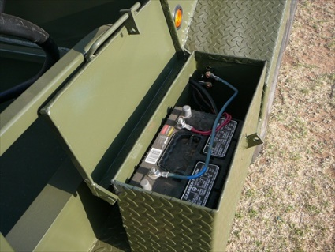
5 | 16 | Pcs | Trading Cutter – 8” – 200mm | 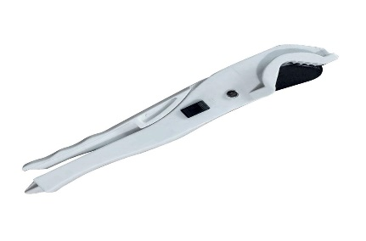
 |  |  |  |  | Total Amount
2 | QTY | UNIT | WELDING AND METAL FABRICATION | PICTORIAL SAMPLE OF ITEMS | UNIT PRICE (NGN) | AMOUNT (NGN)
6 | 30 | Pcs | Bench Vice for Welding and Fabrication work –  Material; cast iron, model HT-V-019, 4 inches. | 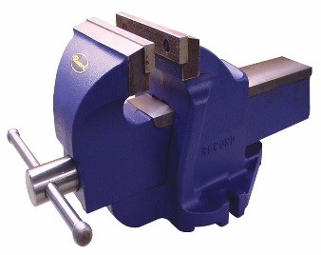
7 | 150 | Pcs | Extension Wire long extension cable reels socket 2.5mm/50m | 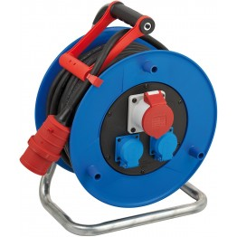
8 | 30 | Pcs | Filing Machine –  HAND FILING MACHINE RE55, Size: 8 Inch, 30 Watt | 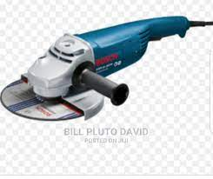
9 | 150 | Pcs | Hacksaw for Welding and Metal Fabrication  Frame 300mm (12") blade lengths 10 to 12 in (250 to 300 mm)
10 | 90 | Pcs | Hammer for Welding and Fabrication work-  2–4 lbs (0.9–1.8 kg) with a 12–14-inch (30–35 cm) handle
11 | 90 | Pcs | Measuring Tape (7-meter tape length) for Welding and Fabrication work (3 x 30 youths)
12 | 150 | Pcs | Tong for Welding and Fabrication work (5 x 30 youths)
13 | 120 | Pcs | Try - Square Welding and Fabrication work Size: 8; Width: 5; Material: Polycast
14 | 30 | Pcs | Welding Machine –  220V MIG Welding Machine, Dimensions: 52 X 31 X 44 cm. Input Capacity 5.2 KVA, Frequency 50 / 60 Hz
15 | 120 | Pcs | Wire for Welding and Metal Fabrication work "2 AWG 625/30." | 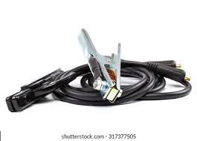
 |  |  |  |  | Total Amount
3 | QTY | UNIT | AUTOMOBILE PAINTING | PICTORIAL SAMPLE OF ITEMS | UNIT PRICE (NGN) | AMOUNT (NGN)
16 | 15 | Pcs | Compressor for Automobile Painting –  15 psi, 10hp compressor capacity | 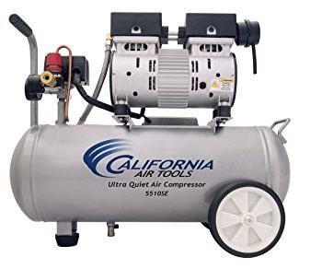
17 | 30 | Pcs | Hose for Automobile Painting –  diameter 3/8 inch, and length 20 to 25 feet | 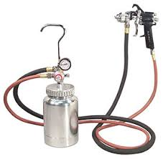
18 | 15 | Pcs | Paint Engine (Machine) for Automobile Painting –  50liter Air Compressor Machine | 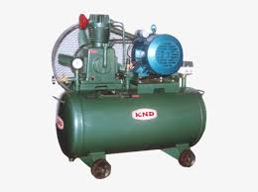
19 | 45 | Pcs | Sanding Block for Automobile Painting  8 inches
20 | 30 | Pcs | Spraying Gun for Automobile Painting size 2.2. Basecoats 1.6 nozzle. Clearcoats 1.7 nozzle.
21 | 30 | Pcs | Tank for Automobile Painting - 26-gallon capacity
22 | 15 | Pcs | Washing Filler Machine for Automobile Painting – 428 x 240px
 |  |  |  |  | Total Amount
4 | QTY | UNIT | AUTOMOBILE WELDING AND PANEL BEATING | PICTORIAL SAMPLE OF ITEMS | UNIT PRICE (NGN) | AMOUNT (NGN)
23 | 15 | Pcs | Block (smoothing block) for Automobile Welding and Panel Beating work
24 | 15 | Pcs | Body Jack Automobile Welding and Panel Beating work – Locally fabricated
25 | 15 | Pcs | Cram Jack Automobile Welding and Panel Beating work –  Locally fabricated | 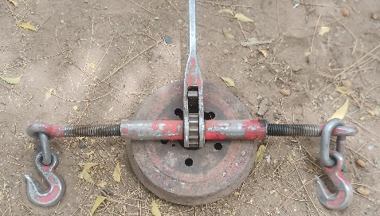
26 | 15 | Pcs | Gas Cylinder Automobile Welding and Panel Beating work. 40Cu/ft. 75% Argon 25% C02 | 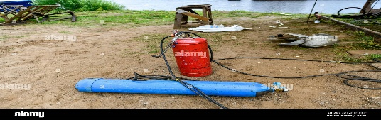
27 | 15 | Pcs | File Machine Automobile Welding and Panel Beating work – 428 x 240px
28 | 15 | Pcs | Gauge Automobile Welding and Panel Beating work –  5/8 BSP Inlet and 3/8BSP Outlet RH  0-10 Bar | 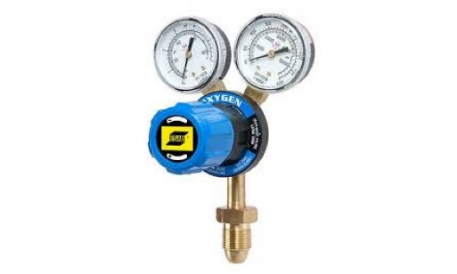
29 | 15 | Pcs | Hand File Automobile Welding and Panel Beating work –  Flat steel blade with serrated teeth and pvc handle. 350 x 35mm
30 | 15 | Pcs | Hose Automobile Welding and Panel Beating work – roll of diameter 3/8 inch | 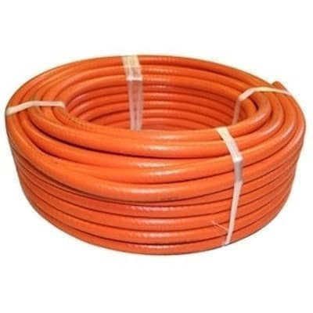
31 | 15 | Pcs | Nozzle Automobile Welding and Panel Beating work –  Oxygen acetylene dual use gas nozzle, length 43.5cm
32 | 15 | Pcs | Set of Spanner Box Automobile Welding and Panel Beating work – 24 sizes of spanner from size 5 to 30
33 | 15 | Pcs | Tanking Cobalt Automobile Welding and Panel Beating work  40Cu/ft. 75% Argon 25% C02
 |  |  |  |  | Total Amount
5 | QTY | UNIT | BAG MAKING | PICTORIAL SAMPLE OF ITEMS | UNIT PRICE (NGN) | AMOUNT (NGN)
34 | 20 | Pcs | Adjust for Bag Making work – locally made
35 | 20 | Pcs | Bag Making yard – different colors, nylon fabric of 25 yards per roll
36 | 20 | Pcs | Decoration materials for Bag Making work – made of ceramic materials
37 | 20 | Pcs | Fiber for Bag Making work –  Polyester materials for water-resistant. Roll of 25 yards
38 | 20 | Pcs | Gum for Bag Making work – 3kg | 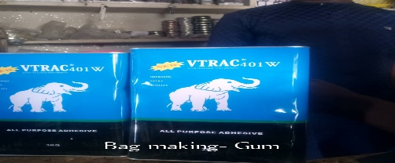
39 | 20 | Pcs | Hakorin Hajiya for Bag Making work – 10 yards
40 | 20 | Pcs | Hammer for Bag Making work  1–4 lbs (0.7–1.6 kg) with a 10–12-inch (30–35 cm) handle
41 | 20 | Pcs | Kurfi for Bag Making work -
42 | 20 | Pcs | Landing for Bag Making work- 50% cotton polyester fibers
43 | 20 | Pcs | Leather for Bag Making work
44 | 60 | Pcs | Malaha 1/2 for Bag Making work
45 | 20 | Pcs | Marco for Bag Making work – thickness 2mm
46 | 40 | Pcs | Metals for Bag Making work -
47 | 100 | Pcs | Pins for Bag Making work - Glass Bead Head Sewing Pins – Multicolor (100 in pack)
48 | 20 | Pcs | Pliers for Bag Making work –  Carbon Steel Plier, multipurpose, Cutting and Holding | 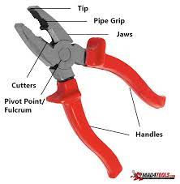
49 | 20 | Pcs | Scissors for Bag Making work - 9-inched sized shears
50 | 20 | Pcs | Sewing Machine for Bag Making work  model JA2-1 | 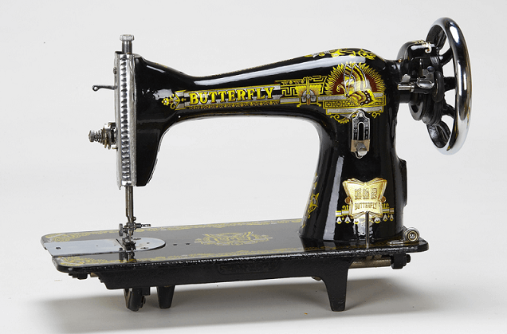
51 | 20 | Pcs | Shafi for Bag Making work – in good quality
52 | 20 | Pcs | Tape (measuring tape)  Tailor Sewing Measuring Tape Rule - 60 Inches
53 | 40 | Pack | Thread - 100% polyester thread, 20 pcs in a pack | 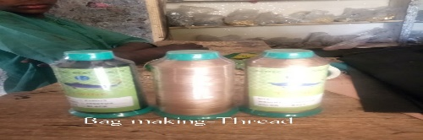
54 | 20 | Pcs | Zik Zag Scissors for Bag Making work – 9” shears
55 | 20 | Pcs | Zips for Bag Making work  Non locking slider, 10 zippers teeth 10mm
 |  |  |  |  | Total Amount
6 | QTY | UNIT | BARBING | PICTORIAL SAMPLE OF ITEMS | UNIT PRICE (NGN) | AMOUNT (NGN)
56 | 22 | Pcs | After Shave for Barbing work – 500ml
57 | 22 | Pcs | Barbing Clippers – Professional barbing clipper with Carbon steel blade and  convenient adjustable control lever
58 | 11 | Pcs | Comb set (2 piece) Plastic of different sizes
59 | 11 | Pcs | Covering Jacket for Barbing work – made of polyester material and able to resist water
60 | 55 | Pcs | Disinfectant - 300 ml spray
61 | 33 | Pcs | Dustin Powder for Barbing work medicated mentholated dusting powder – 80G | 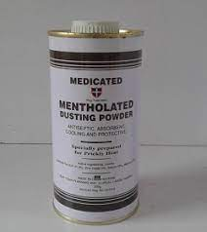
62 | 11 | Pcs | Electric Generator (Small power generator set) - 2.0KVA Generator | 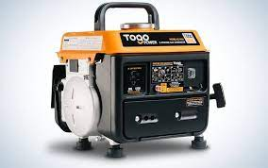
63 | 11 | Pcs | Hairbrush (2 pieces)  Wooden handle air Brush
64 | 11 | Pcs | Wall mount Salon Mirror for Barbing work (30"W x 48"H 2mm, Installed via glue to wall)
65 | 22 | Pcs | Shampoo 2liters
66 | 11 | Pcs | Shaver for Barbing work –  Electric Razors for Shaving, with Extra Replacement Blade LED Cordless Rechargeable Wet/Dry, Cordless
67 | 11 | Pcs | Smoother for Barbing work –  24K gold coated foil blade, 0.05 mm mesh thickness. Rechargeable Electric Razor | 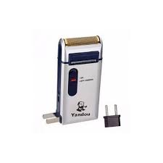
68 | 11 | Pcs | Power Stabilizer (1000 Watts) –  Delayed Function  Multi-functional Socket,  Surge & Shock Protection, Overload Protection, Replaceable Fuse Protection + Wide Input Voltage: 100V-280V | 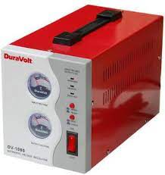
 |  |  |  |  | Total Amount
7 | QTY | UNIT | BICYCLE REPAIRS AND MAINTENANCE | PICTORIAL SAMPLE OF ITEMS | UNIT PRICE (NGN) | AMOUNT (NGN)
69 | 20 | Pcs | 14 Socket for Bicycle Repairs and Maintenance work –  6.5mm long. | 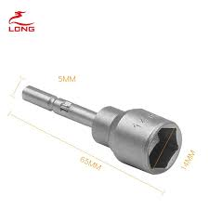
70 | 10 | Pcs | Blow Engine (car damaged engine) for Bicycle Repairs and Maintenance work
71 | 20 | Pcs | Chisel for Bicycle Repairs and Maintenance work –  Chisel, Cold, Flat, 25mm x 300mm
72 | 10 | Pcs | Cold Patch for Bicycle Repairs and Maintenance work  Standard Size, Material: Rubber
73 | 30 | Pcs | Combination Spanners for Bicycle Repairs and Maintenance work  Spanner 22mm
74 | 10 | Pcs | Cycle Steel Ball for Bicycle Repairs and Maintenance work – size 6.35mm | 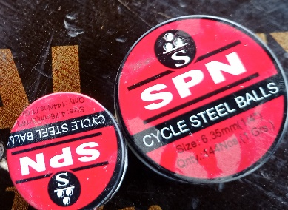
75 | 20 | Pcs | Allen key for Bicycle Repairs and Maintenance work  Hexagon/allen key set, 1.5 - 10mm, 8pce
76 | 50 | Pcs | Flat Spanner for Bicycle Repairs and Maintenance work -  5-17mm Flat Ten in One Bicycle Repair Tools Spanner Wrench
77 | 10 | Pcs | Flat Premium for Bicycle Repairs and Maintenance work  Spanner/Wrench set, Combination, 8mm-22mm
78 | 10 | Pcs | Ganjar (6” wrench pipe) for Bicycle Repairs and Maintenance work  22mm
79 | 30 | Pcs | Grease Oil for Bicycle Repairs and Maintenance work  50ml | 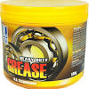
80 | 30 | Pcs | Hammer for Bicycle Repairs and Maintenance work  Hammer, Claw, 450g (16oz) | 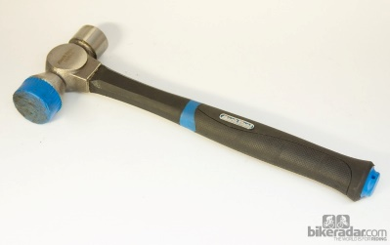
81 | 20 | Pcs | Lever Tire for Bicycle Repairs and Maintenance work  470mm (18")Tyre Lever for Removal of Locking Rings of Tubetye Tyres, Tire Lever
82 | 50 | Pcs | Plier 10 for Bicycle Repairs and Maintenance work Pliers, Combination, 160mm
83 | 20 | Pcs | Air Pump for Bicycle Repairs and Maintenance work  Pump the handle up and down to fill the tube with air.  Compact structure, high pressure pump, high efficiency | 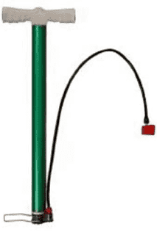
84 | 30 | Pcs | Ring Spanner for Bicycle Repairs and Maintenance work  15mm
85 | 20 | Pcs | Rings for Bicycle Repairs and Maintenance work  Locally fabricated
86 | 30 | Pcs | Screw Drivers for Bicycle Repairs and Maintenance work  Screwdriver, Flat/Slot head, 5mm x 75mm
87 | 20 | Pcs | Shifting Spanners for Bicycle Repairs and Maintenance work
88 | 10 | Pcs | Spanner for Bicycle Repairs and Maintenance work  sizes 6-7mm,
89 | 10 | Pcs | Spoke Wire for Bicycle Repairs and Maintenance work  40mm length | 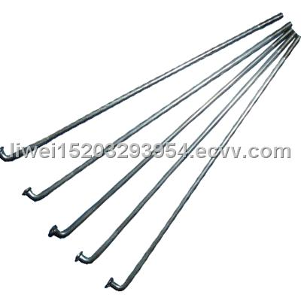
90 | 10 | Pcs | Three Angle Spinner for Bicycle Repairs and Maintenance work  32mm/1/4
91 | 20 | Pcs | Vice for Bicycle Repairs and Maintenance work  Model 604 1/2” swivel 4.5” jaw
 |  |  |  |  | Total Amount
8 | QTY | UNIT | BLACKSMITH | PICTORIAL SAMPLE OF ITEMS | UNIT PRICE (NGN) | AMOUNT (NGN)
92 | 120 | Pcs | Charcoal for Blacksmith work  Dry wood Charcoal
93 | 40 | Pcs | Iron Gas or Firing Bladder for Blacksmiths work  Locally fabricated | 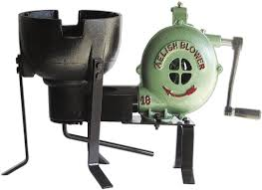
94 | 120 | Pcs | Hammer (Small and Big hammer) for Blacksmith work  Claw, 750g | 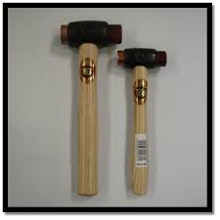
95 | 100 | Pcs | Chisel  3/8" Bevel Edge Socket Chisel
96 | 60 | Pcs | Scissors – singer – shear /C868
97 | 140 | Pcs | Handler:  Blacksmiths' Tong 500g Flat Nosed
98 | 240 | Pcs | Small Hoe for Blacksmith work –  3.25 x 5 in carbon steel blade head forged hoe
99 | 40 | Pcs | Flat Stand  Locally fabricated
100 | 100 | Pcs | Blacksmith Screw  Locally fabricated
 |  |  |  |  | Total Amount
9 | QTY | UNIT | CAP MAKING | PICTORIAL SAMPLE OF ITEMS | UNIT PRICE (NGN) | AMOUNT (NGN)
101 | 26 | Pcs | Blue Landing for Cap Making work – 100% cotton linen materials
102 | 26 | Pcs | Kokuwa for Cap Making work – 100 wool materials | 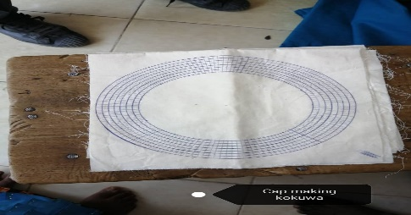
103 | 130 | Pcs | Malti Yard – 100% Polyester material
104 | 26 | Pcs | Needles 1 pack
105 | 130 | Pcs | Thread – 10x10cm | 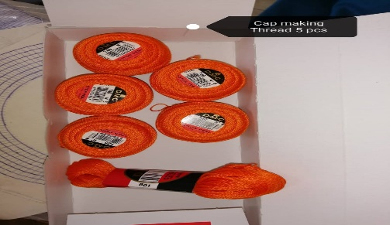
106 | 26 | Pcs | Toliya for Cap making work -10x10cm | 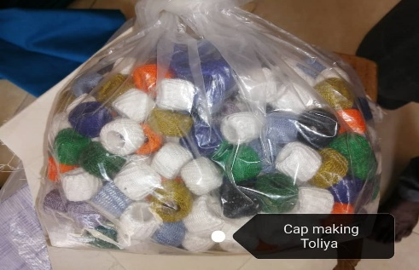
 |  |  |  |  | Total Amount
10 | QTY | UNIT | FURNITURE MAKING | PICTORIAL SAMPLE OF ITEMS | UNIT PRICE (NGN) | AMOUNT (NGN)
107 | 30 | Pcs | Hammer, Claw, 450g (16oz)
108 | 30 | Pcs | Saw –  Hand, 550mm
109 | 30 | Pcs | Measuring Tape - 7-meter length
110 | 15 | Pcs | Jack Plane:  15–18 inches (380–460 mm) long, (180 to 230 mm) long with irons 13⁄4–21⁄2 inches (44–64 mm) wide
111 | 15 | Pcs | Spot Sharp  84 x 54 cm | 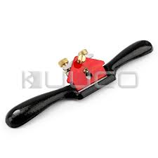
112 | 30 | Pcs | Bar – 5ft, 1 inch, corrosion resistance
113 | 15 | Pcs | Pinches – 12” pinch clamp crimping | 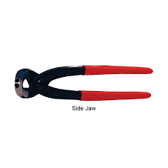
114 | 15 | Pcs | Screw Driver Machine  Cordless Drill Screw Driver-24vols, 13mm Auto - Lock Drill Chuk
115 | 15 | Pcs | Drilling Machine –  28.7 x 25.4 x 7.4 cm; 2.5 Kilograms
116 | 30 | Pcs | Square – 15cm
 |  |  |  |  | Total Amount
11 | QTY | UNIT | GROUNDNUT OIL PROCESSING | PICTORIAL SAMPLE OF ITEMS | UNIT PRICE (NGN) | AMOUNT (NGN)
117 | 150 | Pcs | Bowl - Stainless Steel 28 cm
118 | 50 | Pcs | Processing Machine –  300 – 400Kg/h | 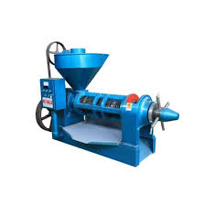
119 | 50 | Pcs | Groundnut Seeds  50 kg bag
120 | 50 | Pcs | Pot Size 10  Locally made - 10 liters
 |  |  |  |  | Total Amount
12 | QTY | UNIT | KNITTING | PICTORIAL SAMPLE OF ITEMS | UNIT PRICE (NGN) | AMOUNT (NGN)
121 | 10 | Pcs | Knitting Machine –  LK150 knitting machine
122 | 50 | Pcs | Wire for Knitting as shown in the picture
123 | 50 | Pack | Wool – weighted 101
 |  |  |  |  | Total Amount
13 | QTY | UNIT | PHONE REPAIRS | PICTORIAL SAMPLE OF ITEMS | UNIT PRICE (NGN) | AMOUNT (NGN)
124 | 13 | Pcs | Computer system for phone Repair work ( Windows 10, 14-inch Screen, 4g Ram, 500 -1000g Rom - Intel)
125 | 26 | Pcs | Extension wire -  High performance extension socket with multiple ports with 6ft long cable & 13 Amp plug | 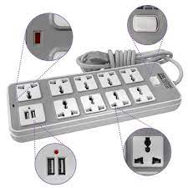
126 | 52 | Pcs | Lead Solder Melting –  Tin 63% / Lead 37% solder and freezes at 183 °C.
127 | 13 | Pcs | Meter for measuring  DC voltage: 200mV-1000V ± (0.5 Percent +1)  AC voltage: 200mV-750V ± (0.8 Percent +3)  DC current: 20mA-20A ± (0.8 Percent +1)  Alternating current: 20mA-20A ± (1 Percent +3)  Resistance: 200Ω-200MΩ ± (2.5 Percent +3)  Capacitance 2nF-200μF | 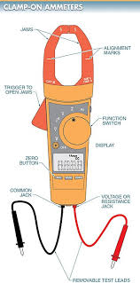
128 | 13 | Pcs | Iron Plate –  Vacuum LCD screen separator with 12 inches heating area
129 | 39 | Pcs | Screw Driver
130 | 26 | Pcs | Soldering Pest – 30g melt at 180C | 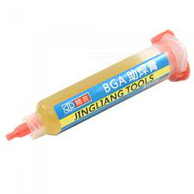
 |  |  |  |  | Total Amount
14 | QTY | UNIT | SHOE MAKING | PICTORIAL SAMPLE OF ITEMS | UNIT PRICE (NGN) | AMOUNT (NGN)
131 | 80 | Pcs | Filling Machine for Shoe Making Work – 6 inches | 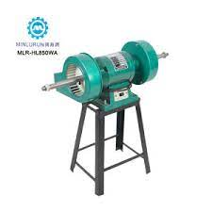
132 | 160 | Pcs | Gum – 3kg
133 | 240 | Pcs | Hammer - Claw, 750g
134 | 80 | Pcs | Pinches -12” pinch clamp crimping
135 | 80 | Pcs | Pencil for drawing show pattern 12” long
136 | 80 | Pcs | Punch – 5/8” (3mm)
137 | 80 | Pcs | Ruler – stainless 1ft long
138 | 80 | Pcs | Scissor –  Scissors, Craft, 125mm (5")
139 | 80 | Pcs | Sewing Machine – JAS2-2
140 | 160 | Pcs | Screw Driver - 5/16 inch Keystone Tip, 6 inch Shank | 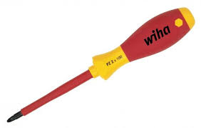
 |  |  |  |  | Total Amount
15 | QTY | UNIT | TAILORING | PICTORIAL SAMPLE OF ITEMS | UNIT PRICE (NGN) | AMOUNT (NGN)
141 | 1850 | Pcs | Brown Paper for Tailoring Work –  Pattern kraft paper-40-450gsm  Sheet size:787”1092mm & 889” 1194mm  Roll 31.86inch
142 | 370 | Pcs | Butterfly Sewing Machine JAS 2-2 stand Rs3500
143 | 1110 | Pcs | Fashion Buttons – sizes: 34L/40L/48L
144 | 1850 | Pcs | Hand Needles- 3/9 / 20 in pack | 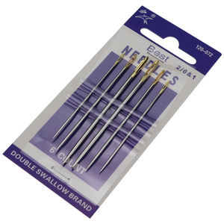
145 | 370 | Pcs | Wooden wall Hanger 2x4”
146 | 1110 | Pcs | Lubrication Oil – 114 ml | 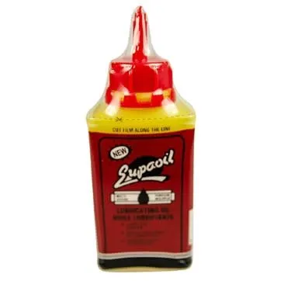
147 | 370 | Pcs | Cloth Material – pure cotton different colors in roll of 10 yards each
148 | 1850 | Pcs | Office Pins (5 x 370 youths)
149 | 370 | Pcs | Electric Pressing Iron  HD1172 1000 Watt Dry Iron, high-quality finished aluminum soleplate | 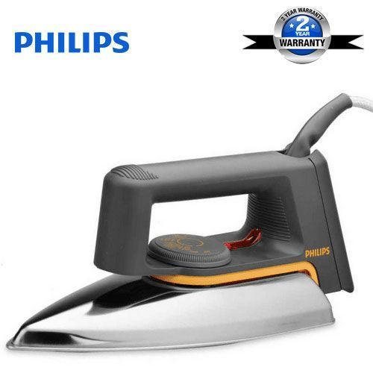
150 | 370 | Pcs | Scissors (Big scissors)  Scissors, Fabric, Large
151 | 1850 | Pcs | Sewing Needles 90/14 pack of 10 | 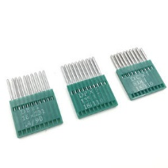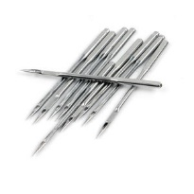
152 | 3700 | Pcs | Weaving Rubber:  100%polyester, cotton, viscose, super white color,
 |  |  |  |  | Total Amount
16 | QTY | UNIT | ALUMINUM WORKS AND GLASS FABRICATION | PICTORIAL SAMPLE OF ITEMS | UNIT PRICE (NGN) | AMOUNT (NGN)
153 | 25 | Pcs | Saw machines for Aluminum Works and Glass Fabrication (Boda Miter Saw M6-255mm Cutting Machine) | 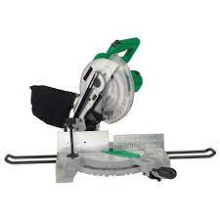
154 | 25 | Pcs | Pointing machine for Aluminum Works and Glass Fabrication-
155 | 25 | Pcs | Driller for Aluminum Works and Glass Fabrication - 12mm | 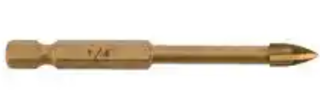
156 | 75 | Pcs | Screw Drivers for Aluminum Works and Glass Fabrication – 6” flat head
157 | 75 | Pcs | Hand Gloves for Aluminum Works and Glass Fabrication- Material: Cotton  Temperature: Withstand Up to 750 degree. Small size
158 | 50 | Pcs | Spinder for Aluminium Works and Glass Fabrication ( 2x 25 youths)  (Diamond Blade for Glass and Tile, 3-3/8" (85 mm))
159 | 25 | Pcs | Diamond Blade for Aluminium works and Glass Fabrication - Tipped Glass Cutter,
 |  |  |  |  | Total Amount
17 | QTY | UNIT | AUTOMOBILE ELECTRICIAN | PICTORIAL SAMPLE OF ITEMS | UNIT PRICE (NGN) | AMOUNT (NGN)
160 | 25 | Pcs | Auto Link Scanner for Automobile Electrician work - 6-foot OBD II cable, USB cable  9V cell battery  Nylon carry case | 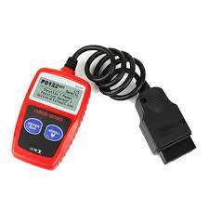
161 | 25 | Pcs | Battery Charger for Automobile Electrician work - Heavy Duty Car Battery Charger-50ams. | 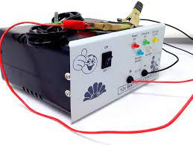
162 | 25 | Pcs | Battery Tester for Automobile Electrician work – HP 12v Alternator & Battery Tester | 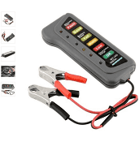
163 | 25 | Pcs | Group Allen key for Automobile Electrician work - 0.7, 0.9, 1.0, 1.25, 1.3, 1.5mm
164 | 25 | Pcs | Hydrometer for Automobile Electrician work –  0.700/1.000 specific gravity a and 10/70 Degree Bsume Dual scale Hydrometer for liquids lighter than water - diameter 50mm | 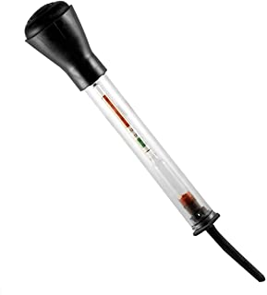
165 | 25 | Pcs | Molar (Mold for car battery heads) for Automobile Electrician work- Locally fabricated
166 | 25 | Pcs | Tester Meter for Automobile Electrician work  Electrical Digital Multimeter Lcd Voltmeter, 0 to 40C  Power: 9V Battery,  Fuse Protection: 200mA/250V Size: 138mm x 69mm x 31mm
167 | 25 | Pcs | Tool Set for Automobile Electrician work: content; 6 sets of screw driver, I grip plier, 1 hold plier, one small size hacksaw, wrench pipe, hammer, 6 set of Allen key, 6 set of spanners.
 |  |  |  |  | Total Amount
18 | QTY | UNIT | PUMP MENDERS MAINTENANCE TOOL KITS | PICTORIAL SAMPLE OF ITEMS | UNIT PRICE (NGN) | AMOUNT (NGN)
168 | 35 | Pcs | Pipe wrench, heavy duty - 14''
169 | 35 | Pcs | Pipe wrench, heavy duty - 10''
170 | 35 | Pcs | Flat head spanners, set of 12 pcs
171 | 35 | Pcs | Plier, flat combination  Carbon Steel Plier, multipurpose, Cutting and Holding
172 | 35 | Pcs | Pinches Clap  Size 8”
173 | 35 | Pcs | Hammer  2–4 lbs (0.9–1.8 kg) with a 12–14-inch (30–35 cm) handle
174 | 35 | Pcs | Hacksaw, with set of blade, original  blade lengths 10 to 12 in (250 to 300 mm)
175 | 280 | Pcs | 3/4'' Brass bronze tap head, original | 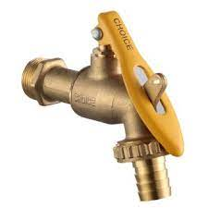
176 | 175 | Pcs | 11/4 " PVC gate valve | 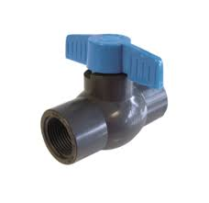
177 | 175 | Pcs | 11/4 " PVC socket
178 | 175 | Pcs | 11/4 " PVC elbow
179 | 175 | Pcs | 11/4 " PVC tee connector
180 | 175 | Pcs | 11/4 " PVC union
181 | 175 | Pcs | 11/4 "x 1" PVC tee connector
182 | 140 | Pcs | 11/4 "x 1" 900 PVC elbow
183 | 140 | Pcs | 1" x 3/4" PVC elbow
184 | 140 | Pcs | 11/4 " x 3/4 " PVC reducer
185 | 70 | Pcs | Telfon tape - 12 mm
186 | 70 | Pcs | Abro gum medium tin size
187 | 35 | Pcs | Wheel Barrow - 145 x 56 x 65 cm. 130kg
188 | 35 | Pcs | Rake – 12 Garden rake with steel handle
189 | 35 | Pcs | Spoon shovle – Garden Shovel with steel handle
190 | 70 | Pcs | Rubber Handglooves  Gloves, rubber, water proof, heavy duty, super grip, one size
191 | 70 | Pcs | Rain boot –  (different sizes), High grade blend of PVC and nitrile rubber,  steel toe caps with 2000 joule rating, mild steel mid sole for penetration  resistant, treated surface for easy cleaning
182 | 35 | Pcs | Mob stick –  100% cotton head, With Wooden or steel Stick, size 4ft
193 | 70 | Pcs | Hard broom Chisel, Cold, Flat, 25mm x 300mm
 |  |  |  |  | Total Amount

Note that Mercy Corps will deduct 5% applicable taxes in accordance with the Nigeria Tax laws

